**E-PHARMACY DATABASE MANAGEMENT SYSTEM**

REVIEW 2 REPORT

Submitted by

**Dhairya Ostwal(19BCE2199)**

Prepared For

**DATABASE SYSTEMS (CSE2004) – PROJECT COMPONENT**

Submitted To

**Dr. Anand Bihari**

**Assistant Professor (Sr)**

**School of Computer Science and Engineering**



**Abstract**

India being a highly vast market for innovation and several products but several studies still show that only 1% pharmacy stores have opted for online mode of doing business.  
(Ref: thepassage.cc article 748)

But seeing today’s era of COVID-19 and continuous lockdown there is an immediate requirement for pharmacy shops to switch to online mode of conducting business. With several telecom & technological players providing affordable data packs and smartphones India since 2014 has seen rise in the use of smartphones in all demographic locations if the country.

Hence this project focusses on database schema and database creation for helping small pharmacy shops transition to online mode of conducting business and hereby expand their customer base with the large customers being available online.

**Keywords**

Pharmacy, Online shop, E-Retail, E-Pharmacy, Medicine, Ecommerce, COVID-19

**Table of Contents**

1. **Introduction to Problem Domain.......................................................................3**
2. **Project SCOPE...........................................................................................3**
3. **Key Contacts and Stakeholders.......................................................................3**
4. **Project Resource Requirements.......................................................................3**
5. **ER Diagram...............................................................................................5**
6. **Relational Database Schema...........................................................................6**
7. **Tables and Constraints............................................................................7, 8, 9**
8. **Work break down.......................................................................................10**
9. **REVIEW EVALUATION..............................................................................10**

**Table of Contents**

1. Introduction 3

2. Project SCOPE 3

3. Literature Review 3

4. **Project Resource Requirements…………………………………………………………….4**

5. ER Diagram 4

6. Tables and Constraints 5

7. Work break down 6

8. REVIEW EVALUATION 6

# Introduction

Every educational institution focuses on reduction of malpractices during examinations and there by establish good standards that contribute towards optimized evaluation processes for their students. As a result the institution can gain credibility in the eyes of the industry by reducing the gap in terms of identifying the right candidate for the various opportunities available. The Malpractice Management System is one such system that focuses on effective utilization of resources towards malpractice management thereby catering towards evaluation process optimization for students and faculty.

Motivation of the project:

# Project SCOPE

Malpractice Management System aims at automation of the following processes

1. Malpractice Registration by faculty members
2. Assignment and communication of enquiry committee members
3. Status tracking of Reported malpractices by students
4. Auto email Generation about the reported malpractice to the proctors and parents of the concerned students
5. Report Generation on the malpractices reported for measuring the effectiveness of the examination conduction process.

# Literature Review

# Project Resource Requirements

## Software Resource Requirements

* Software used
  + Front end
  + Back end

# ER Diagram

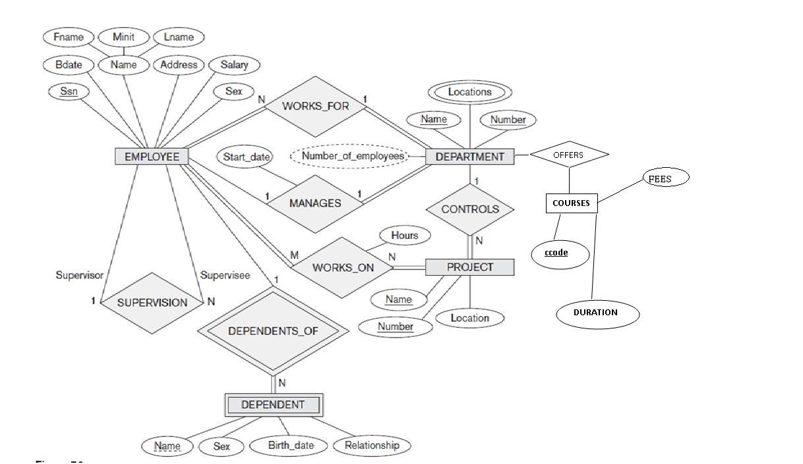

# Tables and Constraints





# Project output

# REVIEW EVALUATION

|  |  |  |  |  |  |  |
| --- | --- | --- | --- | --- | --- | --- |
| COMPONENT | MARKS | MEMBER 1 | MEMBER 2 | MEMBER 3 | MEMBER 4 | MEMBER 5 |
| Review-2- Report | 5 |  |  |  |  |  |
| Project Implementation (60%) | 15 |  |  |  |  |  |
| Review-2-Presentation | 10 |  |  |  |  |  |
| TOTAL | 30 MARKS |  |  |  |  |  |